LISTADO

REFERENCIA | FOTO | COLOR | PRECIO | SURTIDO |  | CAJAS DE | CAJAS DE
 |  |  |  |  |  | 12 PARES | 12 PARES.
 |  | FLUORECENT ORANGE |  | 35-41 | 1232211 | 27
A8880
A8880 |  | FLUORECENT GREEN |  | 35-41 | 1232211 | 359
 |  | BLACK |  | 35-41 | 1232211 | 339
A8881 |  | WHITE |  | 35-41 | 1232211 | 112
 |  | FUCSIA |  | 35-41 | 1232211 | 303
A8882 |  | FLUORECENT FUCSIA |  | 35-41 | 1232211 | 20
A8882 |  | FlUORECENT GREEN |  | 35-41 | 1232211 | 267
 |  | BLUE |  | 35-41 | 1232211 | 51
A8883 |  | GREY |  | 35-41 | 1232211 | 121
 |  | BEIGE |  | 35-41 | 1232211 | 74
A8866 |  | FUCHSIA |  | 40-45 | 123321 |  | 46
AW020551 |  | GREY/BLACK |  | 36-41 | 233211 | 107
AW020559 |  | RED/GREY |  | 36-41 | 233211 | 109
AM020566 |  | RED/BLACK |  | 40-45 | 123321 |  | 36
AW020564 |  | GREY/SKY BLUE |  | 36-41 | 233211 | 94
AW020560 |  | WHITE/BLACK |  | 36-41 | 233211 | 197
AW020560 |  | WHITE/BLACK |  | 40-45 | 123321 | 197
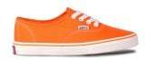
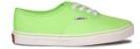
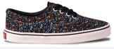
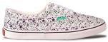
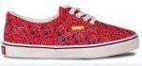
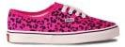
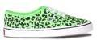
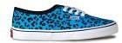
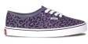
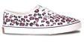
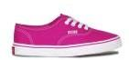
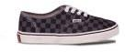
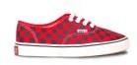
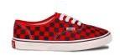
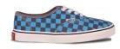
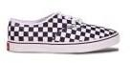

HOJA 1
AW020557 |  | FUXIA/BLUE |  | 36-41 | 233211 | 81
AW020556 |  | WHITE/PINK |  | 36-41 | 233211 | 268
AW020958 |  | BLACK/RED |  | 36-41 | 233211 | 202
AW020965 |  | BLACK/GREY |  | 36-41 | 233211 | 50
AW020966 |  | RED/BLACK |  | 36-41 | 233211 | 10
AW020967 |  | DK.BLUE/GREEN |  | 36-41 | 233211 | 166
AW020968 |  | DK.BLUE/RED |  | 36-41 | 233211 | 103
 |  | FUCSIA |  | 36-41 | 123321 | 106
A8884
A8884 |  | ORANGE |  | 36-41 | 123321 | 90
 |  | FLUORECENT ORANGE |  | 36-41 | 123321 | 306
A8886
A8886 |  | FLUORECENT GREEN |  | 36-41 | 123321 | 17
A8885 |  | KHAKI |  | 36-41 | 123321 | 22
 |  | FLUORENCENT |  | 36-41 | 123321 | 37
 |  | FUCSIA
A8888 |  | FLUORECENT GREEN |  | 36-41 | 123321 | 64
 |  | FLUORECENT ORANGE |  | 36-41 | 123321 | 72
AW0232-01 |  | BLACK |  | 36-41 | 233211 | 227
AW0232-03 |  | BLUE |  | 36-41 | 233211 | 180
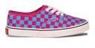
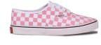
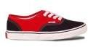
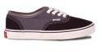
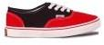
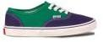
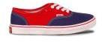
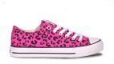
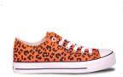
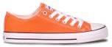
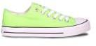
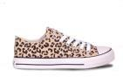
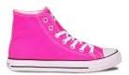
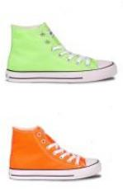
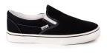
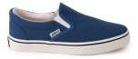

HOJA 2
AW0232-04 |  | RED |  | 36-41 | 233211 | 105
AM0232-04 |  | RED |  | 40-45 | 123321 | 105
AW0232-24 |  | ALL BLACK |  | 36-41 | 233211 | 63
AW0232-82 |  | LEOPARD |  | 36-41 | 233211 | 172
AW0514-01 |  | BLACK |  | 36-41 | 123321 123321 | 294 | 87
AM0514-01 |  | BLACK |  | 40-45 | 123321 123321 | 294 | 87
AW0514-02 |  | WHITE |  | 36-41 | 123321 123321 | 218 | 212
AM0514-02 |  | WHITE |  | 40-45 | 123321 123321 | 218 | 212
AW0514-04 |  | RED |  | 36-41 | 123321 | 303
AM0514-05 |  | DK.GREY |  | 40-45 | 123321 |  | 13
AW0514-06 |  | GREEN |  | 36-41 | 123321 | 572
AW0514-08 |  | FUCSIA |  | 36-41 | 123321 | 409
AM0514-10 |  | WINE |  | 40-45 | 123321 |  | 190
AW0514-17 |  | LT BLUE/SKY |  | 36-41 | 123321 | 280
AW0514-16 |  | DK.BLUE |  | 36-41 | 123321 123321 | 128 | 1
AM0514-16 |  | DK.BLUE |  | 40-45 | 123321 123321 | 128 | 1
AW051501 |  | BLACK |  | 36-41 | 123321 | 652
AW051502 |  | WHITE |  | 36-41 | 123321 | 232
AW051503 |  | BLUE |  | 36-41 | 123321 | 305
AW051504 |  | RED |  | 36-41 | 123321 | 223
AW051508 |  | FUCSIA |  | 36-41 | 123321 | 49
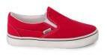
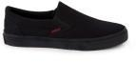
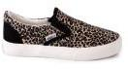
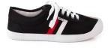
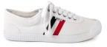
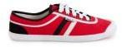
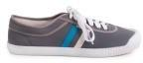
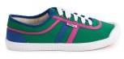
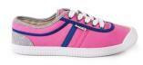
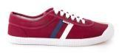
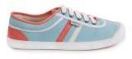
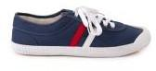
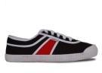
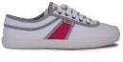
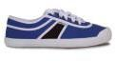
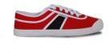
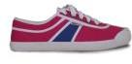

HOJA 3
AW051509 |  | PURPLE |  | 36-41 | 123321 | 397
AW051518 |  | DK.GREY |  | 36-41 | 123321 | 106
AW021902 |  | WHITE |  | 35-41 | 1232211 | 29
AW022003 |  | BLUE |  | 35-41 | 1232211 | 111
AW022004 |  | RED |  | 35-41 | 1232211 | 37
AW022005 |  | GREY |  | 35-41 | 1232211 | 219
AW022006 |  | GREEN |  | 35-41 | 1232211 | 43
AW022009 |  | PURPLE |  | 35-41 | 1232211 | 155
AW022201 |  | BLACK |  | 35-41 | 1232211 | 147
AW022204 |  | RED |  | 35-41 | 1232211 | 61
AW022203 |  | BLUE |  | 35-41 | 1232211 | 31
A8871 |  | BLUE/BLACK |  | 36-41 | 233211 | 231
A8871 |  | DK.BLUE/RED |  | 36-41 | 233211 | 242
A8871 |  | PURPLE/GREY |  | 36-41 | 233211 | 347
A8871 |  | RED/BLACK |  | 36-41 | 233211 | 68
A8871 |  | E.GREEN/KHAKI |  | 36-41 | 233211 | 24
A8871 |  | WHITE/L.T BLUE |  | 36-41 | 233211 | 385
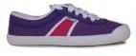
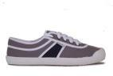
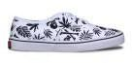
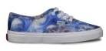
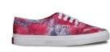
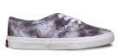
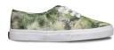
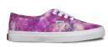
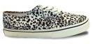
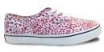
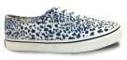
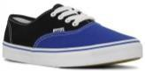
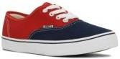
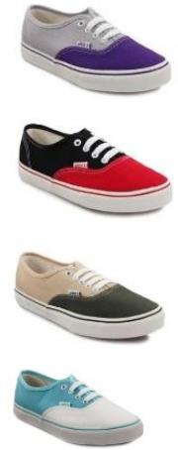

HOJA 4
A8871 |  | YELLOW/DK.BLUE |  | 36-41 | 233211 | 284
A8871 |  | GREEN/BLACK |  | 36-41 | 233211 | 210
A8871 |  | FUCHSIA/BLUE |  | 36-41 | 233211 | 326
A8871 |  | DK BLUE/DK GREY |  | 36-41 | 233211 | 141
A8871 |  | BLACK/WINE |  | 36-41 | 233211 | 32
A8872 |  | GREEN-BLACK |  | 40-45 | 123321 |  | 8
A8865 |  | CAMOUFLAGE |  | 36-41 | 233211 | 228 | 593
A8865 |  | PINK CAMOUFLAGE |  | 36-41 | 233211 | 210
CA01 |  | PINK CAMOUFLAGE |  | 36-41 | 123321 | 127
CA014 |  | CAMOUFLAGE |  | 36-41 | 123321 | 394
CA014 |  | PINK CAMOUFLAGE |  | 36-41 | 123321 | 161
 |  |  |  |  |  | 12932 | 593
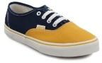
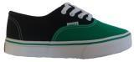
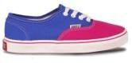
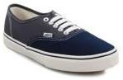
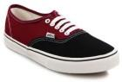
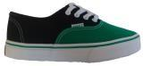
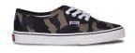
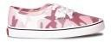
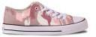
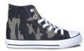
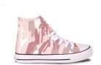

13.525 CAJAS DE 12 PARES.

TOTAL 162.300 PARES.

HOJA 5

